Telecom Customer Churn SQL Query
A. KPI’s
1.Total Customer:
SELECT COUNT(*) AS total_customer
FROM TelecomCustomerChurn;
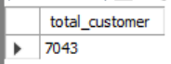

2.Total Churn Customer:
SELECT COUNT(*) AS total_customer_churn
FROM TelecomCustomerChurn
WHERE customer_status = "Churned";
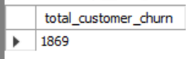

3.New Joined
SELECT COUNT(*) AS new_joined
FROM TelecomCustomerChurn
WHERE customer_status = "Joined";
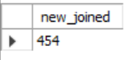

4.Churn Rate %:
SELECT CONCAT(ROUND(COUNT(CASE WHEN customer_status = 'Churned' THEN 1 END) * 100.0 / COUNT(*),2), '%') AS churn_rate
FROM TelecomCustomerChurn;
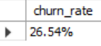

5.Joiner Rate%:
SELECT CONCAT(ROUND(COUNT(CASE WHEN customer_status = 'Joined' THEN 1 END) * 100.0 / COUNT(*),2), '%') AS joiner_rate
FROM TelecomCustomerChurn;
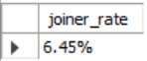

6.Total Revenue:
SELECT SUM(total_charges) AS total_revenue
FROM TelecomCustomerChurn;
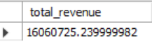

7.Total Revenue Loss:
SELECT SUM(total_charges) AS revenue_loss
FROM TelecomCustomerChurn
WHERE customer_status = "Churned";
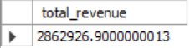

8.% of Revenue Loss:
SELECT
CONCAT(ROUND(SUM(CASE WHEN customer_status = 'Churned' THEN total_charges ELSE 0 END) * 100.0 /SUM(total_charges),2),'%') AS revenue_loss_percent
FROM TelecomCustomerChurn;
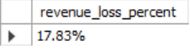

9.Total Revenue By Joiner:
SELECT SUM(total_charges) AS revenue_by_joiner
FROM TelecomCustomerChurn
WHERE customer_status = "Joined";
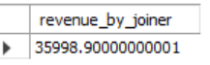

10.Revenue Rate by Joiner:
SELECT
CONCAT(ROUND(SUM(CASE WHEN customer_status = 'Joined' THEN total_charges ELSE 0 END) * 100.0 /SUM(total_charges),2),'%') AS revenue_rate_by_joiner
FROM TelecomCustomerChurn;
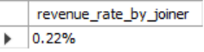

B.CHARTS
1. Churned By Gender:
SELECT
gender,
COUNT(*) AS total_churned,
CONCAT(ROUND (COUNT(*) * 100.0 / SUM(COUNT(*)) OVER (), 1), '%') AS percentage
FROM TelecomCustomerChurn
WHERE customer_status = 'Churned'
GROUP BY gender;
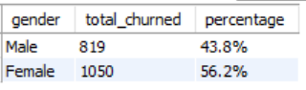

2. Total Churned by Internet Type:
SELECT internet_type,
COUNT (*) AS total_churned
FROM TelecomCustomerChurn
WHERE customer_status = 'Churned'
GROUP BY internet_type
ORDER BY total_churned DESC;
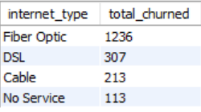

3. Churned By churn categories:
SELECT
churn_category,
CONCAT(ROUND(COUNT(*) * 100.0 /SUM(COUNT(*)) OVER (), 1), '%') AS percentage
FROM TelecomCustomerChurn
WHERE customer_status = 'Churned'
GROUP BY churn_category;
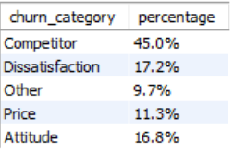

4. Churned Rate By Top 10 Cities:
SELECT
city,
COUNT(*) AS total_churned
FROM TelecomCustomerChurn
WHERE customer_status = "Churned"
GROUP BY city
ORDER BY total_churned DESC
LIMIT 10;
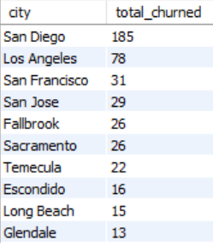

5. Total Customer and Churn Rate By Tenure:
SELECT tenure_group ,
COUNT(*) as total_customer,
CONCAT(ROUND(SUM(CASE WHEN customer_status = "Churned" THEN 1 ELSE 0 END) * 100.0 / COUNT(*) ,2), "%") AS churned_rate
FROM TelecomCustomerChurn
GROUP BY tenure_group
ORDER BY tenure_group ;
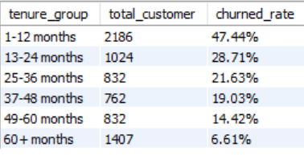

6. Churned By Payment Methods:
SELECT payment_method,
COUNT(*) AS total_churned
FROM TelecomCustomerChurn
WHERE customer_status = 'Churned'
GROUP BY payment_method
ORDER BY total_churned DESC;
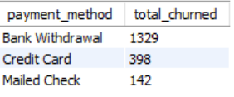

7.Churned By Contract:
SELECT contract,
COUNT(*) AS total_churned
FROM TelecomCustomerChurn
WHERE customer_status = 'Churned'
GROUP BY contract
ORDER BY total_churned DESC;
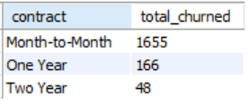

8. CARDS: CUSTOMERS BY SERVICES
-- Internet services:
SELECT count(internet_service) AS YES
FROM TelecomCustomerChurn
WHERE internet_service = "Yes";
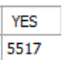
SELECT count(internet_service) AS NO
FROM TelecomCustomerChurn
WHERE internet_service = "No";
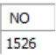

-- Multiple Lines:
SELECT count(multiple_lines) AS YES
FROM TelecomCustomerChurn
WHERE multiple_lines = "Yes";
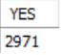
SELECT count(multiple_lines) AS NO
FROM TelecomCustomerChurn
WHERE multiple_lines = "No";
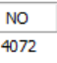

-- Online Security:
SELECT count(online_security) AS YES
FROM TelecomCustomerChurn
WHERE online_security= "Yes";

SELECT count(online_security) AS NO
FROM TelecomCustomerChurn
WHERE online_security= "No";
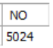

-- Online Backup:
SELECT count(online_backup) AS YES
FROM TelecomCustomerChurn
WHERE online_backup= "Yes";
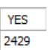
SELECT count(online_backup) AS NO
FROM TelecomCustomerChurn
WHERE online_backup = "No";
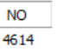

--Streaming TV:
SELECT count(streaming_tv) AS YES
FROM TelecomCustomerChurn
WHERE streaming_tv= "Yes";
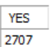
SELECT count(streaming_tv) AS NO
FROM TelecomCustomerChurn
WHERE streaming_tv= "No";
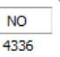

--Streaming Movie:
SELECT count(streaming_movies) AS YES
FROM TelecomCustomerChurn
WHERE streaming_movies= "Yes";
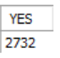
SELECT count(streaming_movies) AS NO
FROM TelecomCustomerChurn
WHERE streaming_movies= "No";
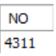

-- PremiumTech Support:
SELECT count(premium_tech_support) AS YES
FROM TelecomCustomerChurn
WHERE premium_tech_support= "Yes";
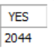
SELECT count(premium_tech_support) AS NO
FROM TelecomCustomerChurn
WHERE premium_tech_support= "No";
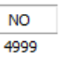

--Unlimited Data:
SELECT count(unlimited_data) AS YES
FROM TelecomCustomerChurn
WHERE unlimited_data = "Yes";
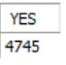
SELECT count(unlimited_data) AS NO
FROM TelecomCustomerChurn
WHERE unlimited_data= "No";
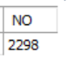

C.Revenue Analysis:
1.Revenue Loss By Contract:
SELECT contract,
SUM(total_charges) AS revenue_loss
FROM TelecomCustomerChurn
WHERE customer_status = "Churned"
GROUP BY contract
ORDER BY revenue_loss DESC;
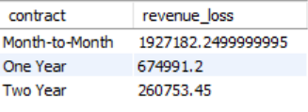

-- Revenue Loss By Category:
SELECT churn_category,
SUM(total_charges) as revenue_loss,
ROUND(SUM(total_charges)*100.0/SUM(SUM(total_charges)) OVER(),2) AS percentage
FROM TelecomCustomerChurn
WHERE customer_status = "Churned"
GROUP BY churn_category
ORDER BY revenue_loss DESC;
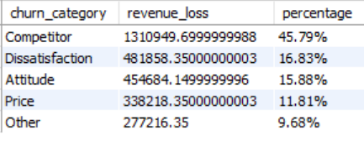

-- Total Revenue and Loss Rate By Contract:
SELECT tenure_group,
SUM(total_charges) as total_revenue,
CONCAT(ROUND(SUM(CASE when customer_status = "Churned" then total_charges ELSE 0 END) * 100.0 / SUM(total_charges) ,2), "%") AS churned_rate
FROM TelecomCustomerChurn
GROUP BY tenure_group
ORDER BY tenure_group;
